**Light Emitting Navigation System for the Visually Impaired**

ECE 4011 Senior Design Project

LENS

Dr. James Hamblen

Dr. Brian Gay

Malavika Bindhi

David Clyde

Anushri Dixit

Daniel Fulford

James Fulford

Submitted

November 21, 2016

**Table of Contents**

**Executive Summary** iii

1. **Introduction** 1
   1. Objective 1
   2. Motivation 2
   3. Background 3
2. **Project Description and Goals** 4
3. **Technical Specification** 5
4. **Design Approach and Details**
   1. Design Approach 6
   2. Codes and Standards 10
   3. Constraints, Alternatives, and Tradeoffs 11
5. **Schedule, Tasks, and Milestones** 11
6. **Project Demonstration** 12
7. **Marketing and Cost Analysis** 13
   1. Marketing Analysis 13
   2. Cost Analysis 14
8. **Current Status** 16
9. **References** 17

**Appendix A** 21

**Appendix B** 22

**Appendix C** 23

**Executive Summary**

With all of the advanced technology currently in the market, the most common two tools used to aid visually impaired individuals navigating in their environment is a simple cane or walking stick and guide dog. The goal of LENS or Light Emitting Navigation System is to create an affordable device that can be worn comfortably on the head for extended periods of time to help a user successfully navigate in their environment without the need for a stick or dog. LENS will have a headgear apparatus similar to many virtual reality headsets currently in the market to house the microcontroller, battery, and the LIDAR sensor that will be used to operate the device. LENS will use a single LIDAR sensor to scan the user’s environment. Once the sensor is done scanning, it will send the data to an mbed microcontroller which will then send out a signal accordingly to either a haptic motor or a pair of ear buds depending on the user preference. If the haptic feedback option is chosen a motor will vibrate with different pulse frequencies that are dependent on the distance to objects read by the sensors. If the audio feedback option is chosen a soothing tune from a cello will be played and sent to headphones worn by the user. Similarly, with the haptic feedback option the cello note will change frequencies and volume based on distance. The total cost of all the individual parts will be $360. With all of the Labor, marketing and other sales expenses the total cost of the device will be $790. With a $60 profit gain, the selling price of the device in the market will be $850. Team LENS expects to have a decent working prototype by the project deadline in May, 2017.

**Light Emitting Navigation System (LENS) for the Visually Impaired**

**1. Introduction**

The LENS team will design comfortable headgear to be worn by a visually impaired user in order to provide navigation assistance. Specifically, the device is to provide real-time haptic feedback to alert the user of walkway obstacles, so the user is able to safely navigate in his or her environment. The team is requesting 400$ to develop a prototype.

* 1. **Objective**

The team will design and implement a prototype headgear that utilizes light detection and ranging, or LIDAR, sensor technology to detect objects and provide sensible feedback to the user in either audio or tactile format depending on user preference. The wearable headgear housing for all the electronics of the system will follow a similar design scheme as seen with virtual reality headsets available today. These headsets normally support cellular phones or tablets and so they provide adequate support and comfort to be worn for extended periods of time. The headgear will internalize a closed loop system handled by a microcontroller that processes the input from at least one LIDAR sensor into haptic feedback sensed by the user. The haptic feedback will be comprised of two options using a vibrotactile option and an auditory option to be selected by the user.  As the user walks, the headgear will provide intuitive feedback that alerts the user based on distance to obstacle that allows the user to adjust their walking trajectory appropriately.

* 1. **Motivation**

The most common technology used by the visually impaired today consists of a cane or a dog travel guide. The sponsor for this project, Dr. Brian Gay, recalls an event he once visited that was hosting a visually impaired navigation experience. During this event, they gave patrons like Brian a walking stick and then would turn off the lights in several rooms and allow each patron to navigate in the dark in order to simulate the visually impaired experience. Brian summarized his experience as enlightening and spent his ride home after the event trying to conceptualize an idea that would be commercially cost effective and superior to a walking stick. He finally came up with a basic idea that involved headgear, detection sensors and sound that would alert the user in a superior navigation system compared with a walking stick. Other options for the visually impaired exist that are available and improve walking sticks using ultrasonic sensors [1]. However, low hanging objects still remain a major source of head injury for the visually impaired [2]. The team seeks to reduce this amount using headgear that also works more efficiently than a traditional cane. Furthermore, expensive visual prosthetics are being developed that seek to provide some actual vision back, but these are not viable for the entire visually impaired population and cost over 100,000$ [3, 4]. The aim in this team’s design is to provide a cost effective approach that at a minimum reduces the need for a cane and provides adequate navigation indoors with the possibility of other environments.

* 1. **Background**

There are many researchers developing and improving electronic travel aids (ETAs) to help the visually impaired navigate through their surroundings. Benjamin et al created a cane which uses laser beams to detect overhead objects, waist level obstacles, and drop-offs [5]. The Ecole Polytechnique Fédérale de Lausanne (EPFL), is a shoulder-mounted ultrasound system with vibration motors to provide feedback for the user [6]. Others have made navigational systems much like the one presented in this proposal. In the journal article “Multi-Section Sensing and Vibrotactile Perception for Walking Guide of Visually Impaired Person,” an ETA is presented. The system created by Gu-Young Jeong and Kee-Ho Yu, uses only ultrasonic sensors where the user wears on their head. Tactile feedback is provided to the user’s hands by the use of vibration motors. Tests were performed by blind individuals and feasibility was confirmed if sensory distance was increased and a learning period was provided [5]. Most ETA projects implement ultrasound as their range finders [5]. Much of the research shows that ultrasonic sensors are preferred. The team sought to determine what sensor would be most efficient. The initial work began with testing ultrasonic sensors followed by LIDAR. The team’s early testing led to the assertion that ultrasonic sensors are not sufficiently accurate and are sensitive to circuit and sound interference especially when using more than one sensor. Thus, the team opted for the more accurate and stable readings of LIDAR sensors. The team decided to utilize one LIDAR sensor and begin the project in the Spring with this scheme in mind.

1. **Project Description and Goals**

The major goal for this team is to design an autonomous navigational system for people with impaired vision that improves typical navigation and potentially removes the need of the cane. The navigational system will consist of headgear, microcontroller, LIDAR and ultrasonic sensors, vibration motors, and headphones. The headgear will be designed and fabricated following a similar design scheme as modeled by virtual reality headsets. The headgear will be a platform for the system to be installed on. The microcontroller will be programmed to take readings from the LIDAR sensor. The microcontroller will also allow the user to select between which feedback they prefer: audio or haptic feedback. Distance readings from the sensors will be used to output a haptic feedback to vibration motors or musical notes to the headphones. The Project goals are as follows:

**General**

* The user will feel more comfortable navigating in their environment
* Low cost to enhance affordability

**Range Finding Sensors:**

* At least one LIDAR sensor for object detection
* Wide beam via single sensors or an array to enhance resolution
* Optimized power consumption via cycled pulses

**Haptic Feedback**

* Vibration intensity and frequency modulation based on distance
* Audio intensity and frequency modulation based on distances

1. **Technical Specifications**

|  |  |
| --- | --- |
| **Table 1.** Head Gear and System Housing Specifications | |
| **Feature** | **Specification** |
| Dimensions | 17cm x 13cm x 9cm |
| Weight | 450g -550g |
| Material | Plastic and Aluminum |

|  |  |
| --- | --- |
| **Table 2.** Closed Feedback System Specifications | |
| **Feature** | **Specification** |
| MCU Processing Speed | > 96 MHz |
| MCU Operating Voltage | 5V |
| Obstacle detection range | 0.1m – 35m |
| Detection Accuracy | +/- 5cm |
| LIDAR Sensor Voltage | 4V- 6V |
| Detection Refresh Time | < 100 ms |
| Vibration Motor Voltage | 1.5V – 3.3V |
| Feedback Response Time | 100ms -200ms |
| Battery Supply | 7.4V – 8.2V | 2000 mAh – 3000 mAh (Li -ion) |
| Operating Life | 8 – 12 Hrs (continuous use) |

|  |  |
| --- | --- |
| **Table 3.** Headphones | |
| **Feature** | **Specification** |
| Style | Earbuds |
| Frequency Bandwidth | 20Hz-20kHz |
| Impedance | > 10 Ω |
| Sensitivity | 85 dBs |
| Connection Jack Size | 3.5mm |
| Cable Length | 1.5m |

1. **Design Approach and Details**
   1. **Design Approach**

*System Overview*

The LENS prototype will consist of earbuds, a headgear apparatus, microcontroller, vibration motor(s), LIDAR sensor, and DSP codec chip for audio. Figure 1 displays the entire LENS.

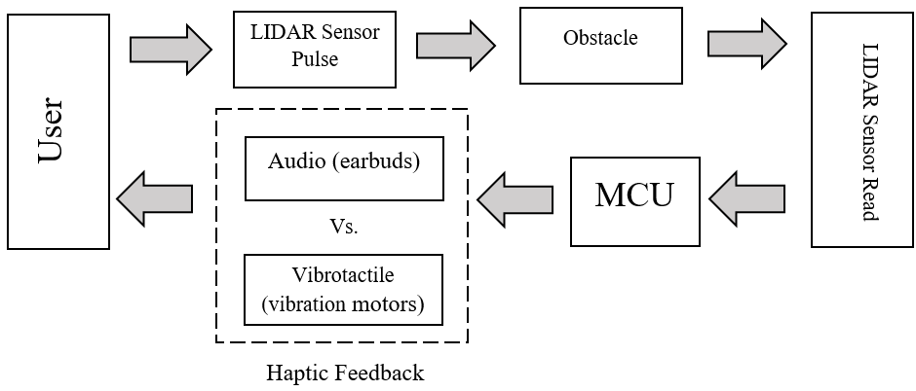

**Figure 1.** Block diagram for closed loop navigation system LENS using haptic feedback.

Figures 2 and 3 display a rough prototype of the system the team constructed utilizing a purchased virtual reality (VR) headset, an Arduino board and a LeddarTech LIDAR sensor.

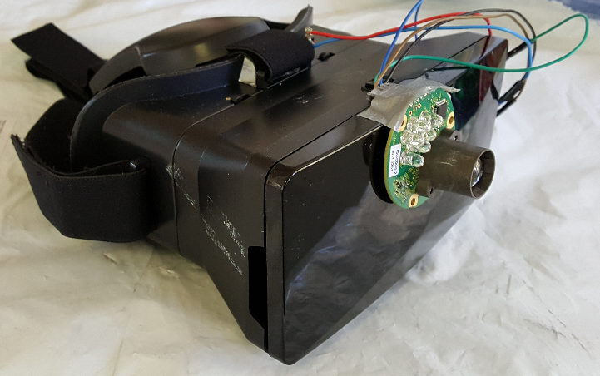

**Figure 2.** Early Prototype of LENS project (lateral orientation)

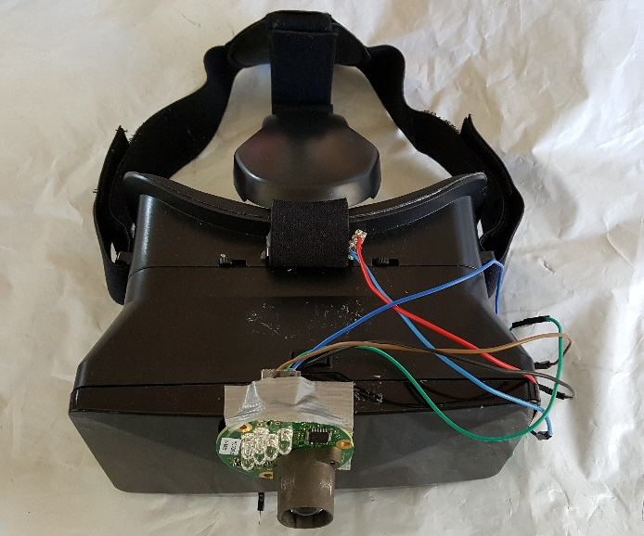

**Figure 3.** Early Prototype of LENS project (top orientation)

This will be quite different then the proposed solution which will utilize an MBED board shown in Figure 4. and a LIDAR-lite v3 instead [7]. Additionally, instead of a VR headset, the team will construct its own custom design to decrease weight while providing greater durability and comfort. The team plans to accomplish this through fabrication using aluminum and plastic composite, and 3D prints. The design will be similar to a VR headset, but designed specifically to house and mount the entire electronics of the system.

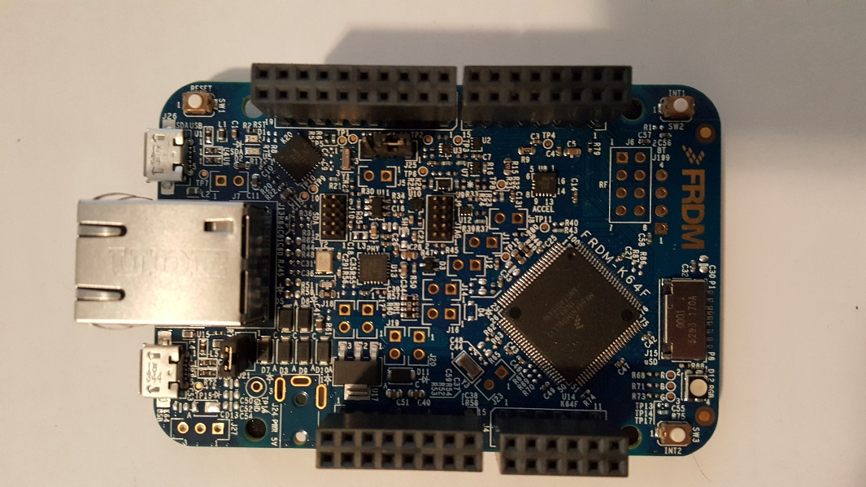

**Figure 4.** FRDM-K64F MBED microcontroller used in the LENS

*Auditory Option*

The LENS project will contain an auditory feedback option. A button will be provided to enable switching between auditory and vibrotactile feedback. If the system is set in audio mode, a cello note will be played. The note will be played at a linear rate in relation to varying distance. The pitch, play rate, and volume will be increased as the object draws closer. As the object moves away, the pitch, play rate, and volume will decrease to silence outside 10 feet. The cello note will be sent to earbuds for hearing. The cello notes will be stored as MP3 files on a micro SD card which will be sent to a MircoSD breakout decoder as seen in Figure 5. The decoder allows sound files to be produced with clarity.

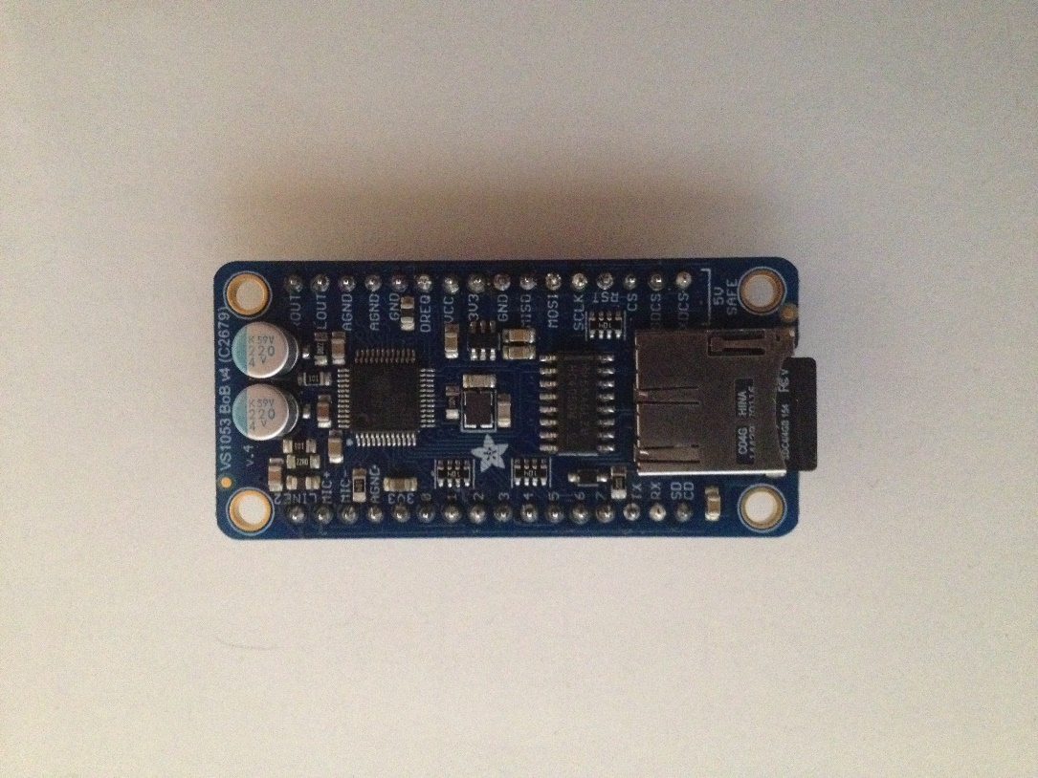

**Figure 5.** Adafruit VS1053 Codec used to decode saved sound files on a MircoSD card

*Vibrotactile Option*

This option will operate in a similar manner as the team’s proposed audio option. The vibrotactile option provides the user the ability to swap when using the device in loud environments or for personal preference. Essentially, the LIDAR sensor will pulse and determine the distance to obstacles. The threshold as before is still 10 feet before the feedback is engaged. At distances 10 feet or less, the feedback will engage using a vibration motor based on an algorithm that will

linearly ramp up the intensity based on shortening distances to obstacles to alert the user for course correction. Figure 6 shows the vibration motors used for feedback.

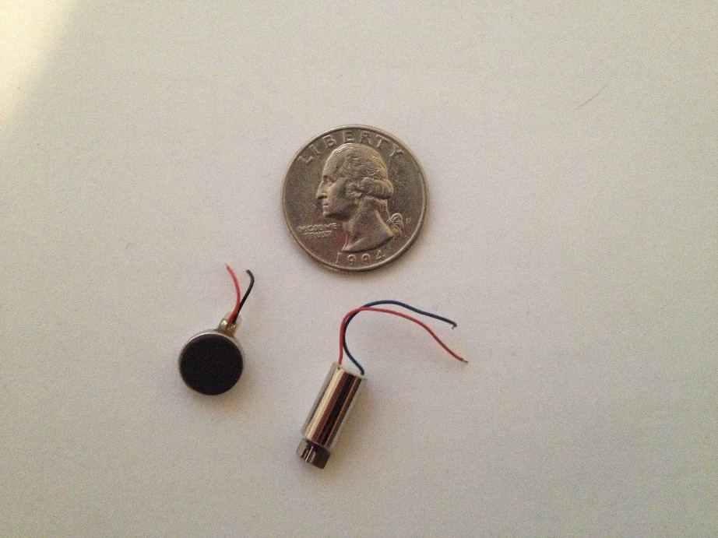

**Figure 6.** Linear resonant actuators (LRA) vibration motor (left) and eccentric rotating mass (ERM) vibration motor (right) used for haptic feedback

In addition to a ramp, the vibration motor will be set to pulse with increasing or decreasing frequency based on closer or further distances respectively within threshold. Furthermore, the vibration motor operation will be assessed using either an LRA or ERM, shown in Figure 5, based on intensity and power consumption. Also, the motor will be driven either through a basic motor driver construction or using a haptics controller [8, 9]. Figure 7 shows the haptic controller that can be used to control the vibration motors.

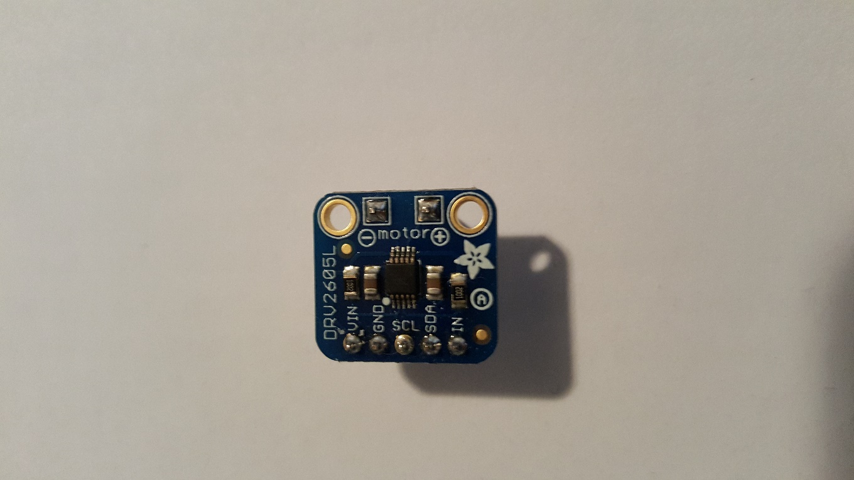

**Figure 7.** Adafruit DRV2605L Haptic Motor Controller used to control the vibration motors

* 1. **Codes and Standards**

1. I­­2C Communication Protocol

* A serial protocol to share data between the LIDAR sensor and microcontroller.
* Allows multiple slave integrated chips to communicate with multiple masters [10].
* I2C bus specification details the connections, protocols, formats, addresses, and procedures that define the rules on the bus.
* Also used for communication between haptic feedback sensor and microcontroller.

1. Universal Serial Bus (USB)

* For communication between microcontroller and PC.
* PC can thus act as a power supply for microcontroller.
* High-speed signaling bit rate of 480Mbps [11].

1. Inter-IC Sound (I2S)

* Serial bus interface standard used for communication with VS1053 [12].
* This interface is used to only handle external DAC.

1. Musical Instrument Digital Interface (MIDI)

* Standard that describes protocol for communication between electronic musical instruments and computers [13].
* MIDI sounds are utilized to provide feedback to user.
  1. **Constraints, Alternatives, and Tradeoffs**

An alternative to the LIDAR is the ultrasonic sensor. The ultrasonic sensors are, however, inferior to the LIDAR in terms of range and sensitivity to noise. Usage of two or more ultrasonic sensors instead of a LIDAR also makes the headgear more susceptible to cross talk. Hence, the LIDAR makes a better choice for the project despite being more expensive and consuming more power. Because the headgear will be worn on a regular basis by the visually impaired, its weight has to be minimized. This is done by using one, extremely accurate LIDAR instead of numerous inaccurate sensors.

1. **Schedule, Tasks, and Milestones**

Team LENS will be completing the project during spring 2017. Appendix A shows the task breakdown and person in charge of each task along with difficulty/ risk level of the task. A GANTT chart describing the identified milestones is shown in Appendix B. A PERT chart showing the critical path and durations of each task is provided in Appendix C.

1. **Project Demonstration**

The demonstration of the prototype can take place in any room in Van Leer because it is portable and easy to use for the visually impaired. The main criterion for evaluation is easy navigation through any environment.

*Navigation through an unknown setting*

An unbiased volunteer will be asked to navigate through a maze-like environment unknown to him/her. The maze-like environment will be constructed and continuously varied by rearranging desks and chairs in a classroom in Van Leer. If the volunteer is able to navigate through different settings without colliding with an obstacle, the test is successful.

*Navigation by multiple people*

Several people should be able to navigate through an environment without colliding with an obstacle. This demonstrates that everyone easily understands the output from the headgear.

*Longevity of headgear*

The headgear should last for 8-12 hours on battery without charging and remain comfortable to the user with a lightweight construction.

1. **Marketing and Cost Analysis**
   1. **Marketing Analysis**

285 million people are estimated to be visually impaired worldwide according to statistics provided by the World Health Organization [14]. Out of this, 39 million are blind, while the other 246 million have low vision. LENS would be targeting this population, to provide them better quality of life. Some similar products have been developed to assist visually impaired people with navigation. Haptic Assisted Location of Obstacles (HALO) is a device developed by Steve Strubing and uses vibrations as the output, informing the user about the presence of an obstacle in his/her path [15]. This device uses an Arduino MEGA 2560 microcontroller. The product is still in the development stage, but the current testing results show the discomfort and confusion caused by haptic feedback. A similar commercial product, called iGlasses Ultrasonic Mobility Aid, is also available and costs $130. This product is developed as a secondary assistive device which would complement a traditional cane or guide dog [16]. The use of musical notes instead of haptic feedback differentiates these products from LENS. Musical notes, which are more soothing to the ears, would remove the discomfort caused by vibrations. LENS provides the user with a choice between musical feedback and haptic feedback. Also, LENS is designed to be used alone without additional assistance from traditional aids for visually impaired.

Another similar project is an object detection and guidance system for the visually impaired by Al-Shehabi et al. [17]. They use a Microsoft Kinect Sensor, a tablet PC and an ATMEL XMEGA A1 microcontroller to develop a headgear for the visually impaired. The use of Kinect causes portability issues. Smaller sensors used in LENS eliminate this problem.

* 1. **Cost Analysis**

*Parts and Materials*

The materials needed to create a headgear prototype are given in Table 1 along with their unit costs. The most significant cost is that of the LIDAR. The LIDAR, however, is more effective for the headgear than a simple ultrasonic sensor that is cheaper. The prices given for fabrication materials and circuit materials are approximate. These materials can be obtained from the Senior Design Lab without cost.

**Table 1. Component costs for prototype**

|  |  |
| --- | --- |
| **Parts** | **Cost** |
| Microcontroller [18] | $59.95 |
| LIDAR sensor [19] | $149.99 |
| Vibration Motor [20] | $4.95 |
| Adafruit MP3 Board [21] | $24.95 |
| Haptics Driver [22] | $7.95 |
| Battery [23] | $22.50 |
| Earbuds [24] | $19.99 |
| Circuit components (resistors, capacitors, wires, PCB, etc.) | $30 |
| Fabrication and packaging materials (Aluminum, plastics, etc.) | $40 |
| **Total** | **$360.28** |

*Development Costs*

The total development cost of the headgear is $63,254. The team consists of 6 members, and the estimated hours to be worked on the project for each member are given in Table 2. Assuming a labor cost of $40/hour, the total development costs have been calculated in Table 3.

**Table 2. Development hours for the group**

|  |  |  |  |
| --- | --- | --- | --- |
| **Tasks** | **Labor hours per person** | **Labor cost per person** | **Total cost for six members** |
| Weekly meetings and reports | 30 | $1,200 | $8,400 |
| Presentations | 1 | $40 | $240 |
| Building circuit | 25 | $1,000 | $6,000 |
| Circuit testing | 10 | $400 | $2,400 |
| Software development | 20 | $800 | $4,800 |
| Code debugging | 5 | $200 | $1,200 |
| **TOTAL** | **91** | **$3,640** | **$21,840** |

If the fringe benefits are considered to be 30% and the overhead costs of materials and labor are to be 120%, the total development cost can be calculated as shown in Table 3. The total is $63,254.

**Table 3. Total development costs**

|  |  |
| --- | --- |
| **Development Component** | **Cost** |
| Parts | $360 |
| Labor | $21,840 |
| Fringe benefits, % of labor | $6,552 |
| Subtotal | $28,752 |
| Overhead, % of material, Labor, and Fringe benefits | $34,502 |
| **Total Development Cost** | **$63,254** |

Assuming that 5000 units are sold over a 5-year period, the profits are calculated as shown in Table 4. When bought in bulk, the total parts cost is reduced to $288. If the headgear were sold for $850 per unit, a profit of $60 per unit would be made. With technicians working on assembly and testing for $30/hour, and advertisement costing 5% of the selling price, the subtotal is $790 for each unit. While $850/unit is much higher than the cost of similar headgears available in the market currently, this is the only headgear that provides full autonomy without a cane.

**Table 4. Selling Price and Profit per unit**

|  |  |
| --- | --- |
| **Parts Cost** | **$288** |
| Assembly labor | $20 |
| Testing labor | $10 |
| Total labor | $30 |
| Fringe benefits, % of labor | $9 |
| Subtotal | $327 |
| Overhead, % of material, Labor, and Fringe benefits | $393 |
| Subtotal, input costs | $720 |
| Sales expense | $42.5 |
| Amortized development cost | $28 |
| Subtotal, all costs | $790 |
| **Profit** | **$60** |
| **Selling Price** | **$850** |

1. **Current Status** The team spent time over the summer working on the project. The team was able to get a basic prototype working using an Arduino Uno and LeddarTech LIDAR sensor. Currently, almost all the components have been purchased. The LeddarTech LIDAR is a decent sensor, but it is not as user friendly as the LIDAR Lite-v3 and does not have helpful code libraries available. However, at the time of purchase it was the only cost effective LIDAR available. The Lite-v3 released this fall. Thus, the Lite-v3 was chosen since it has more support and is more user friendly. In addition, the Arduino platform was abandoned since these boards are not powerful enough to handle the processes the LENS system will demand. The mbed was selected and tested against the arduino with greater response and overall system stability. Once the proposal has been approved, the LIDAR Lite-v3 will be bought and construction of a second prototype can begin using the mbed MCU mentioned above.
2. **References**

[1] M. Senthilingam, “Sonar sticks use ultrasound to guide blind people,” in *CNN,* CNN, 2014. [Online]. Available: http://www.cnn.com/2014/06/20/tech/innovation/sonar-sticks-use-ultrasound-blind/. Accessed: Nov. 20, 2016.

[2] Roberto Manduchi PhD and Sri Kurniawan PhD, "Mobility-Related Accidents Experienced by People with Visual Impairment," *Insight: Research and Practice in Visual Impairment and Blindness*, vol. 4, no. 2, Feb. 2011. [Online]. Available: https://users.soe.ucsc.edu/~manduchi/papers/MobilityAccidents.pdf. Accessed: Nov. 20, 2016.

[3] D. Graham-Rowe, "A Bionic eye comes to market," MIT Technology Review, 2012. [Online]. Available: https://www.technologyreview.com/s/423216/a-bionic-eye-comes-to-market/. Accessed: Nov. 20, 2016.

[4] P. Lewis, H. Ackland, A. Lowery, and J. Rosenfeld, "Restoration of vision in blind individuals using bionic devices: A review with a focus on cortical visual prostheses," *Brain Research*, vol. 1595, pp. 51–73, Nov. 2014. [Online]. Available: http://www.sciencedirect.com/science/article/pii/S0006899314015674. Accessed: Nov. 20, 2016.

[5] G.-Y. Jeong and K.-H. Yu, "Multi-section sensing and Vibrotactile perception for walking guide of visually impaired person," vol. 16, no. 7, Jul. 2016. [Online]. Available: https://www.ncbi.nlm.nih.gov/pmc/articles/PMC4970117/. Accessed: Nov. 20, 2016.

[6] S. Cardin, D. Thalmann, and F. Vexo, "Wearable System for Mobility Improvement of Visually Impaired People,". [Online]. Available: https://pdfs.semanticscholar.org/e86d/49f813622d4a918abc201dbbf38cfd444e46.pdf. Accessed: Nov. 20, 2016.

[7] Member, "SparkFun logic level converter - bi-directional," 2016. [Online]. Available: https://www.sparkfun.com/products/14032. Accessed: Nov. 2, 2016.

[8] "How to build a vibration motor circuit,". [Online]. Available: http://learningaboutelectronics.com/Articles/Vibration-motor-circuit.php. Accessed: Nov. 20, 2016.

[9] A. N. Whitehead, "Overview,". [Online]. Available: https://learn.adafruit.com/adafruit-drv2605-haptic-controller-breakout/overview. Accessed: Nov. 20, 2016.

[10] Contributors, "I2C,". [Online]. Available: https://learn.sparkfun.com/tutorials/i2c. Accessed: Nov. 20, 2016.

[11] *Universal Serial Bus Specification*, Revision 2.0 ed. Hewlett Packard, 2000. [Online]. Available: http://sdphca.ucsd.edu/lab_equip_manuals/usb_20.pdf. Accessed: Nov. 20, 2016.

[12] "VS1053b - Ogg Vorbis/MP3/AAC/WMA/MIDI AUDIO CODEC," *VS1053b*, vol. Version 1.01, May 2008. [Online]. Available: https://www.sparkfun.com/datasheets/Components/SMD/vs1053.pdf. Accessed: Nov. 20, 2016.

[13] *MIDI 1.0 Detailed Specification*, Version 4.2 ed. L.A. California: MIDI manufacturers Association, 1995. [Online]. Available: http://oktopus.hu/uploaded/Tudastar/MIDI%201.0%20Detailed%20Specification.pdf. Accessed: Nov. 20, 2016.

[14] WHO, "Visual impairment and blindness," in *World Health Organization*, World Health Organization, 2016. [Online]. Available: http://www.who.int/mediacentre/factsheets/fs282/en/. Accessed: Nov. 20, 2016.

[15] N. Khan, "HALO for the visually impaired," Walyou, 2010. [Online]. Available: http://walyou.com/haptic-assistance-for-the-blind/. Accessed: Nov. 20, 2016.

[16] Ambutech, "IGlasses ultrasonic mobility aid- clear lens," 1986. [Online]. Available: https://www.maxiaids.com/iglasses-ultrasonic-mobility-aid-clear-lens. Accessed: Nov. 20, 2016.

[17] M. Al-Shehabi et al., "An Obstacle Detection and Guidance System for Mobility of Visually Impaired in Unfamiliar Indoor Environments", *IJCEE*, vol. 6, no. 4, pp. 337-341, 2014.

[18] Amazon, "FREESCALE SEMICONDUCTOR FRDM-K64F DEV BOARD, MK64FN1M0VLL12 ETHERNET/USB," in *Amazon.com: Industrial & Scientific*, Amazon, 1996. [Online]. Available: https://www.amazon.com/FREESCALE-SEMICONDUCTOR-FRDM-K64F-MK64FN1M0VLL12-ETHERNET/dp/B00L3R69A4. Accessed: Nov. 20, 2016.

[19] Member, "SparkFun logic level converter - bi-directional," 2016. [Online]. Available: https://www.sparkfun.com/products/14032. Accessed: Nov. 20, 2016.

[20] Member, "Solenoid - 5v (small)," 2015. [Online]. Available: https://www.sparkfun.com/products/8449. Accessed: Nov. 20, 2016.

[21] A. Industries, "VS1053 Codec + MicroSD Breakout - MP3/WAV/MIDI/OGG play + record [v4] ID: 1381 - $24.95: Adafruit industries, unique & fun DIY electronics and kits,". [Online]. Available: https://www.adafruit.com/product/1381. Accessed: Nov. 20, 2016.

[22] J. L. Borges, "Overview,". [Online]. Available: https://learn.adafruit.com/adafruit-drv2605-haptic-controller-breakout/overview. Accessed: Nov. 20, 2016.

[23] KIRA, "7.2V 7.4V 2* 18650 3100mAh 2S lithium ion Li-ion battery pack [2x 18650 2S 7.4V 3100mAh Battery] - $22.50: Lithium rechargeable batteries, battery BMS, pack assembling," 2016. [Online]. Available: http://www.batterysupports.com/72v-74v-2-18650-3100mah-2s-lithium-ion-liion-battery-pack-p-71.html. Accessed: Nov. 20, 2016.

[24] runner 630, "Skullcandy - ink’d 2 Earbud headphones - black," Best Buy, 2012. [Online]. Available: http://www.bestbuy.com/site/skullcandy-inkd-2-earbud-headphones-black/6461052.p?skuId=6461052. Accessed: Nov. 20, 2016.

**Appendix A: Tasks, Person Assigned, and Risk/Difficulty Level**

|  |  |  |
| --- | --- | --- |
| Task Name | Person in charge | Risk / Difficulty Level |
| **Obstacle Detection** |  |  |
| Interfacing LIDAR sensor with microcontroller | AD | Low |
| Processing the received sensor data | DF | High |
| Mapping the position of obstacles detected by sensors | AD, DF | High |
| **Sound Feedback** |  |  |
| Interfacing speaker modules with microcontroller | JF | Medium |
| Determining sound patterns for feedback | MB | Low |
| Utilizing mapped sensor information to match sound patterns | JF, MB | Medium |
| **Haptic Feedback** |  |  |
| Interfacing haptic feedback sensor with microcontroller | DC | Medium |
| Determining vibration patterns for feedback | MI | Low |
| Haptic feedback based on mapped sensor data | MI, DC | Medium |
| **Assembly of Device** |  |  |
| Design the overall system assembly | MI, JF, DF | Low |
| Assemble device | All | Medium |
| **Testing** |  |  |
| Test the functionality of assembled device | All | Medium |
| Improvements | All | Medium |
| **Documentations and Presentations** |  |  |
| Project Proposal | All | Low |
| Presentation and Final Demo | All | Medium |
| Final Project Report | All | Low |

**Appendix B: GANTT Chart**

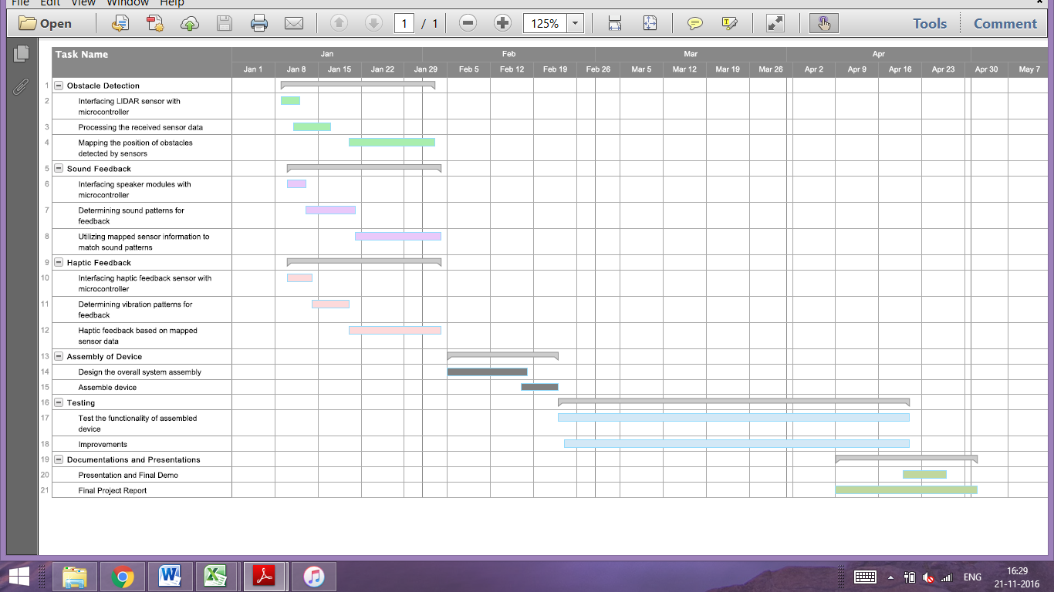

**Appendix C: PERT Chart**

